“Nitka” – coming soon to Łódź
This fall, the organizers of the Łódź Design Festival will present a new art installation inspired by the city's textile heritage. "Nitka," created by renowned Polish designer Izabela Bołoz, will be installed in the passage connecting Art_Inkubator and the Fuzja complex.
In the passage connecting Art_Inkubator and the multifunctional Fuzja complex, an object will be created to symbolically integrate the two spaces, functioning separately for a long time, although historically forming a unified cultural landscape. The form of the installation will visualize the idea of “stitching” the places together, referring to a thread unrolling from a spool, “passing” through the layers of the tract between the two post-factory areas.
The idea of the project refers to the textile traditions of Łódź and the industrial complex of the town once owned by cotton tycoon Karol Scheibler. The installation will play the role of an element identifying the place and a testimony to the local, urban identity. The appearance of an artistic object with an interactive character in the rediscovered space will allow its social revival. The project will be aesthetically simple, devoid of decorative style or historical imitation, and is not intended to compete with the post-industrial architecture of the area.
The installation is initiated by the Łódź Art Center Foundation as part of the year-round Łódź Design Festival program, in collaboration with the multifunctional Fuzja complex. The author of the installation is Izabela Bołoz (Studio Boloz).
Subsidized from the funds of the own program of the Center of Polish Sculpture in Oronsko titled Sculpture in Public Space for the Independent – 2024 from the budget of the Minister of Culture and National Heritage. [Funding value: 80,000.00 PLN. Total investment cost: 94,270.00 PLN. Date of signing the agreement: June 2024].
More information: lodzdesign.com/en/nitka
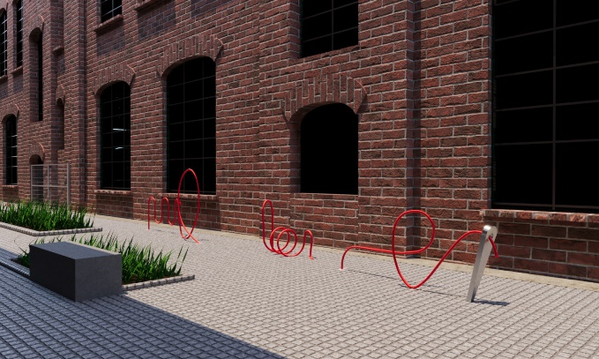 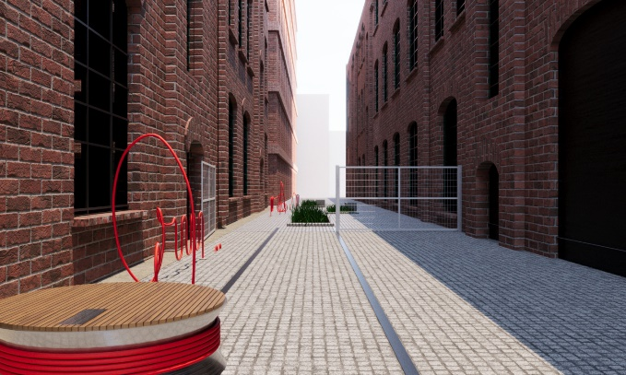
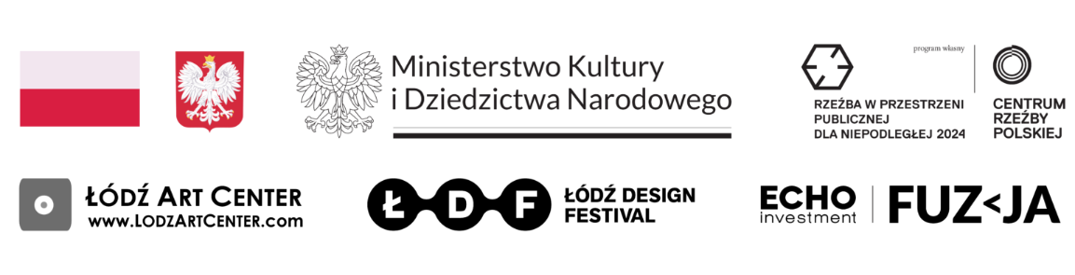
“Nitka” – an art installation, design: Izabela Bołoz / visualization

