Polish Job 2.0. Design That Matters
Polish Job 2.0 is a cross-sectional exhibition of Polish design brands prepared by Łódź Design Festival. The presentation is an opportunity to analyse the contemporary Polish market and review the most interesting products awarded in the must have plebiscite, organised by Łódź Design Festival.
Polish design review
Polish Job 2.0 is a cross-sectional exhibition representing the Polish design brand, its characteristics and uniqueness, prepared by Łódź Design Festival. The presentation is an opportunity to analyse the contemporary Polish market, review the most interesting products and an attempt at capturing the criteria identifying brand consistency. During the first edition of Polish Job at Milan Design Week in 2014, three interrelated themes of Polish design were presented: locality, nostalgia and innovation. The current perspective shows that Polish design, apart from drawing on regional motifs and resources, reworking retro designs, or experimenting with new solutions, is also defined by responsibility and resourcefulness. Polish designers are increasingly coming up with more efficient or ethical solutions, minimising waste or taking a creative approach to reusing existing resources during production. All five categories intermingle and merge in the projects and implementations selected for the exhibition. The prepared collection will show current trends, the development of individual brands, the evolution of products and the most promising directions of design development in Poland.
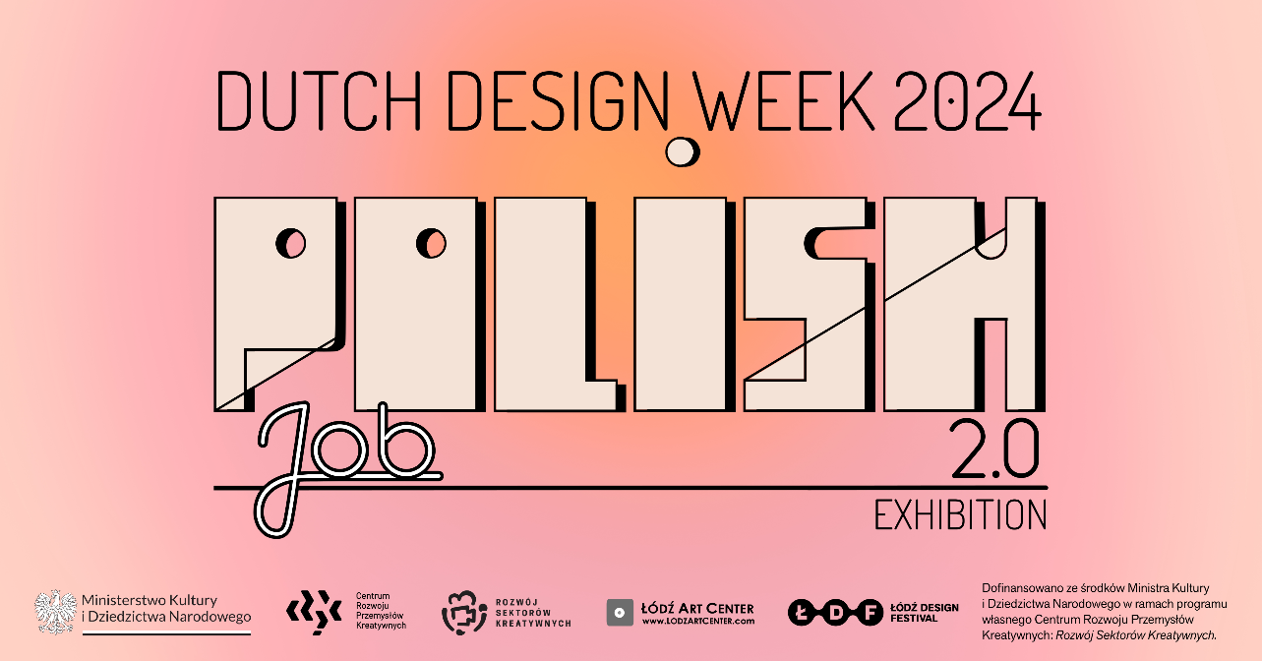
must have plebiscite discovers Polish market trends
The must have plebiscite is one of the most important part of the Łódź Design Festival. Since 2011, a Board of Experts has been following the changes and innovations in Polish design, awarding the must have quality label to products available on the Polish market that are innovative, socially conscious, created with care for resources, and notable for their ingenuity. The plebiscite inspires designers to work on innovative solutions and encourages companies to invest in design as a key element of their market strategy.
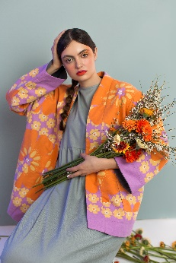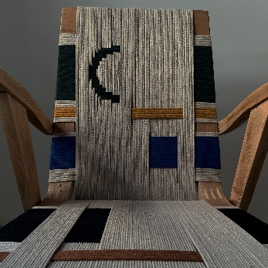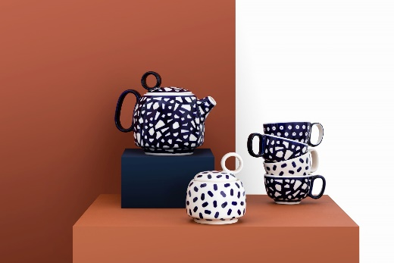
In the run-up to the Polish Job 2.0 exhibition, nearly 1,000 products awarded in the must have plebiscite were reviewed and the Polish design brand was identified. Despite the huge diversity of domestic design, the main values guiding designers and producers revolve around five intertwining concepts: innovation, responsibility, resourcefulness, locality, and nostalgia. The collection selected for presentation reflects the contemporary character of Polish design and the directions of its development, carrying the promise of continuous improvement and a fresh look at the international trends, at the same time combining tradition with a guarantee of product quality. The partner of the Polish Job 2.0 exhibition is VANK.
Adres
fffunction.studio
Halvemaanstraat 18H
5651 BP Eindhoven
Netherlands

Opening hours
19-26.10.2024 / 11:00-18:00,
27.10.2024 / 11:00-16:00.

Colophon
Łódź Design Festival – exhibition concept
Bogusława Bronowicka – curatorial collaboration
Małgorzata Jaguszewska – exhibition production
Aleksandra Kietla – promotion & PR
Katarzyna Ludwisiak – graphic & exhibition design
Hanna Nadolska – production support
Michał Piernikowski – curating & content creation
Łukasz Piernikowski – technical coordination
About Łódź Design Festival
Łódź Design Festival is the most important Polish event dedicated to design in the broadest sense. The programme combines artistic and social activities, with exhibition creators commenting on the challenges of the contemporary world. Building a multi-threaded and multi-media narrative, showing the continuity and development of Polish design thought and presenting exceptional projects that change our reality for the better are the elements that distinguish the ŁDF.
lodzdesign.com | Facebook | Instagram | Twitter | YouTube | LinkedIn

